High Level Design Document

**Purchasing capabilities of a customer**

Version 1.0

04/09/2021

|  |  |  |  |
| --- | --- | --- | --- |
| Version | Description | Responsible Party | Date |
| 1.0 | Initial version | Mayur Jiwtode | 04-09-2021 |

# Abstract:-

Businesses need to be aware of consumer buying power because it affects what products and services people spend their money on.Consumer power is affected by the economy and inflation. For example, when prices rise as a result of economic trends, consumers have less buying power because the same product may cost more. As a result, a consumer may become more frugal with their spending habits and think twice about buying a new product or service.

For a small business, understanding consumer buying power can help determine how to price individual products and services. If your demographic has lower consumer buying power, for example, it’s likely they will be looking for low-priced products and services. If they have higher consumer buying power, they can likely spend more money on the same products and services..

# Introduction

## Why this is a High-Level Design Document?

The purpose of this High-Level Design (HLD) Document is to add the necessary detail to the current project description to represent a suitable model for coding. This document is also intended to help detect contradictions prior to coding andcan be used as a reference manualfor how the modules interact at a high level.

* + 1. Present all the design aspects and define them in detail
    2. Describe the user interface being implemented
    3. Describe the hardware and software interfaces
    4. Describe the performance requirements
    5. Include design features and the architecture of the project
    6. List and describe the non-functional attributes like
       - Security
       - Reliability
       - Maintainability
       - Portability
       - Reusability
       - Application compatibility
       - Resource utilization
       - Serviceability

## Scope

The HLD documentation presents the structure of the system, such as the database architecture, application architecture (layers), application flow (Navigation), and technology architecture. The HLD uses non-technical to mildly-technical terms which should be understandable to the administrators of the system.

## Definition

|  |  |
| --- | --- |
| **Term** | **Description** |
| Cassandra Database | Collection of all information monitored by this application |
| AWS | Amazon Web Services |
| IDE | Integrated Development Environment |

# General Description

## Product perspective

The purchasing capabilities of customers is a machine learning based model designed to help businesses to understand behaviours of customer on buying and spending the money on product and services , so that they can effectively price, sell and market their product.

## Problem Statement:-

Customer Segmentation is the subdivision of a market into discrete customer groups

that share similar characteristics. Customer Segmentation can be a powerful means to

identify unsatisfied customer needs. Using the above data, companies can then

outperform the competition by developing uniquely appealing products and services.

The most common ways in which businesses segment their customer base are:

1. **Demographic information** includes gender, age, familial and marital status, income,

education, and occupation.

2. **Geographical information** which differs depending on the scope of the company.

For localized businesses, this info might pertain to specific towns or counties. On the

other hand, it might mean a customer’s city, state, or even country of residence for

larger companies.

3. **Psychographics**, such as social class, lifestyle, and personality traits.

4. **Behavioural data**, such as spending and consumption habits, product/service usage,

and desired benefits.

Advantages of Customer Segmentation

1. Determine appropriate product pricing.

2. Develop customized marketing campaigns.

3. Design an optimal distribution strategy.

4. Choose specific product features for deployment.

5. Prioritize new product development efforts. You have to create a project to segment a

customer for a banking client based on their transaction history. You have to find out the

purchasing capabilities of customers for a different part of the customer.

## Proposed Solution:-

Customer segmentation refers to the practice of separating customers into discrete groups, or segments, based on shared characteristics, such as age, gender, common interests, or spending habits. This model is segmenting the group of customer with similar traits regarding their transaction history by extracting the necessary information of their behaviours on the products and services that they buy and which they don’t buy.

## Further Improvements:-

## Technical Requirements

* + 1. Proper computing power to process requests and fetch data from server.
    2. Proper methodology for implement the algorithms.

## Tools Used

* PyCharm and VS Code as IDE.
* Python Flask as backend.
* Apache Cassandra to retrieve, insert, create and update databases.
* GitHub is used as version control system.
* AWS is used for deployment..
* Docker used to containerize our application.
* Docker-compose is used to link the docker containers.

  

  

## Constraints

The application must be user friendly, as automated as possible and users should not be required to know any of the workings.

# Design Details:-

## Process Flow:-

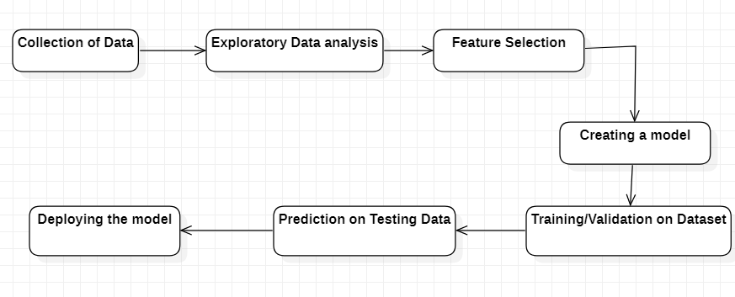

We have used a web application with flask as backend along with Cassandra as database.

## Event Handling

1. The System identifies at what step logging required

2. The System can log each system flow.

3. We have used database logging in Cassandra.

4. System does not hang even after using so many loggings. Logging is mandatory just because we can easily debug issues.

## Error Handling

Should errors be encountered, an explanation will be displayed as to what went wrong? An error will be defined as anything that falls outside the normal and intended usage.

# Performance

## Reusability:-

The code written, and the components used should have the ability to be reused with no problems

## Application Compatibility:-

The different components for this project will be using Python as an interface between them. Each component will have its own task to perform, and it is the job of the Python to ensure proper transfer of information.

## Resource Utilization:-

When any task is performed, it will likely use all the processing power available until that function is finished.

## Deployment:-



Conclusion:-

By segmenting the user depending on the purchasing capabilities ,our model can help the today’s businesses to sell and make the product and services that the most of the customer is buying.